This QRG outlines the steps to add access to a Cost Center and includes instructions to manage calendar templates, including creating, editing, and deleting. This will most often be used by the Business Office, who is responsible for summer pay calendars. Business Office staff are encouraged to proactively set up the work templates to make entry quicker.

Access the Summer Pay Tool
Visit OneCampus and select SEEMLESS. | OneCampus https://one.purdue.edu/
Log in using Purdue Career Account ID and Password

Settings
Once logged in, the Dashboard is displayed
Click Show My Settings under the name

Adding Access to Cost Centers
Click the Cost Centers tab.  Highlight a line, lick on New. | 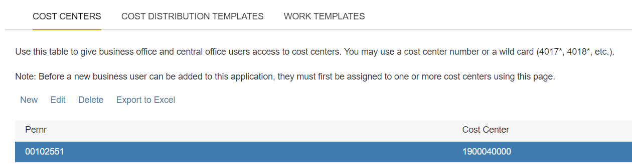
Enter Cost Center number.  An asterisk * will give access to the full department.  Click Save. | 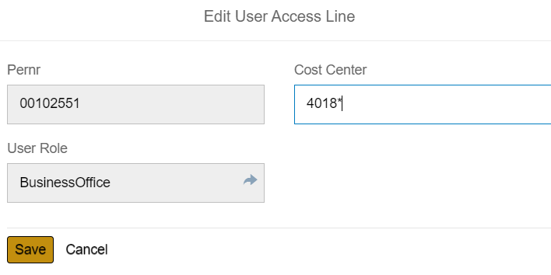
Access to the Cost Center(s) is added for that individual. | 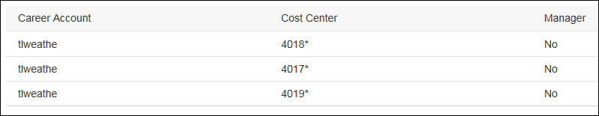
Highlight a line, then Click Edit or Delete to make changes on the Cost Center. | 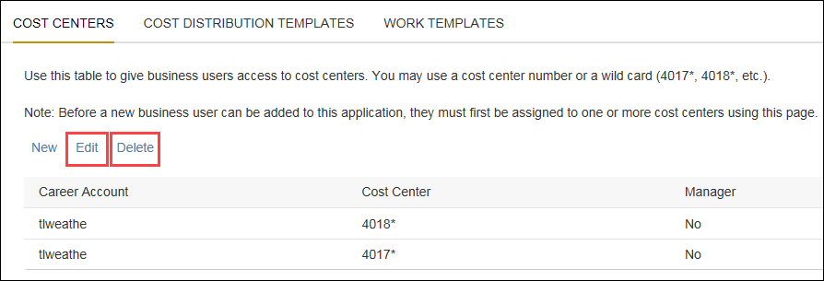

Work Templates – Create
Open the Calendar for the Pay period, select the dropdown option under EDIT  Click the Use Template | 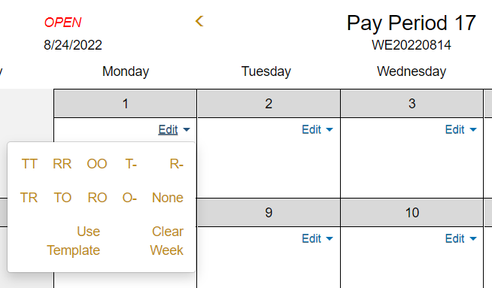
Either Select the Pre-populated templates at the right and/or select Add Template to create your own schedule  Click the corresponding radio button to select the appropriate schedule for each day. | 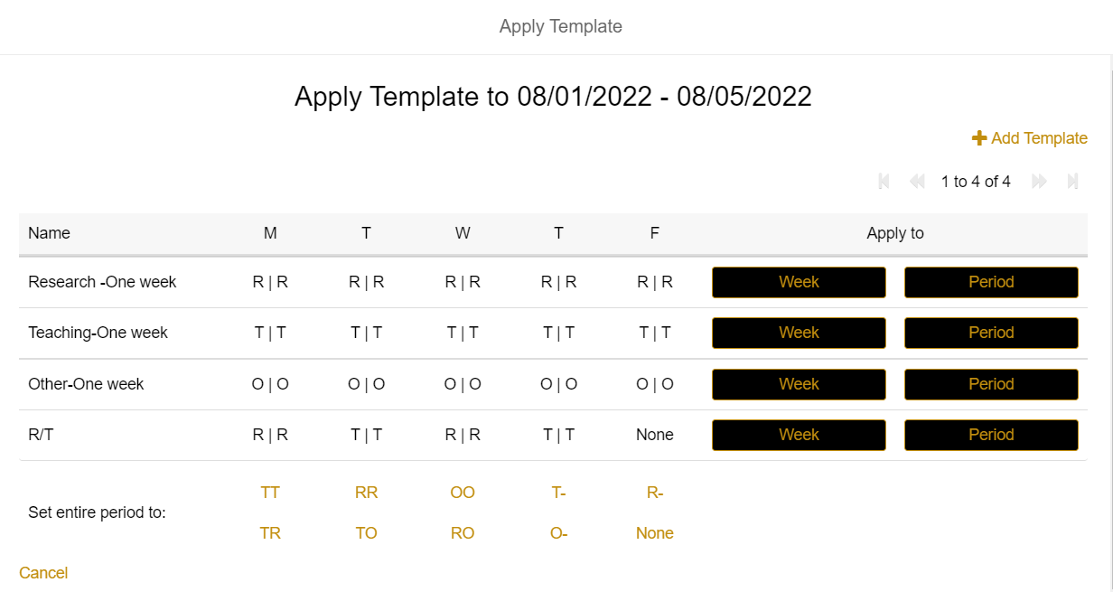  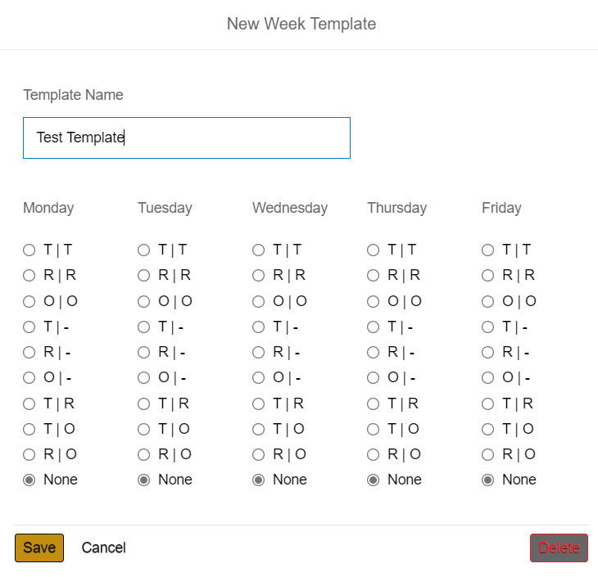
Click Save.

